**Identification of Place of Interest**

**A**

**MINOR PROJECT REPORT**

**Submitted for the partial fulfillment of the requirement for the award of Degree**

**B.E.**

**IN**

**COMPUTER SCIENCE & ENGINEERING**

****

**Submitted by: Submitted to:**

**Prashant Wable - 0101CS151082 Prof. Dr. Piyush Shukla**

**Priyanka Rajak - 0101CS151085 Prof. Rohit Agrawal**

**Rohit Choudhary - 0101CS151095**

**Rudra Pratap Singh - 0101CS151098**

**DEPARTMENT OF COMPUTER SCIENCE & ENGINEERING**

**UNIVERSITY INSTITUTE OF TECHNOLOGY - RAJIV GANDHI PROUDYOGIKI VISHWAVIDHYALAYA BHOPAL (M.P.)**

**BHOPAL- 462033**

**SESSION 2015-2019**

**UNIVERSITY INSTITUTE OF TECHNOLOGY**

**DEPARTMENT OF COMPUTER SCIENCE AND ENGINEERING**

****

**RAJIV GANDHI PROUDYOGIKI VISHWAVIDHYALAYA BHOPAL (M.P.)**

This is to certify that **Prashant Wable, Priyanka Rajak, Rohit Choudhary** and **Rudra Pratap Singh Tomar** of B.E 3rd Year, Computer Science & Engineering have completed their 3 minor project entitled “**Identification of Place of Interest** ” during academic year 2016-2017 under my guidance and supervision.

We approve the project for the submission for the partial fulfilment of the requirement for the award of degree in Computer Science & Engineering.

**Dr. Piyush Shukla Prof. Rohit Agrawal**

Professor Assistant Professor

Project Guide Project Guide

**Dr.** **R.K.** **Rajput Dr.Sanjay Silakari**

Director HOD CSE

UIT RGPV Bhopal UIT RGPV Bhopal

**DECLARATION BY THE CANDIDATES**

We hereby declare that the work which is being presented in the Minor Project entitled “**Identification of Place of Interest** ” submitted for the partial fulfilment of the requirement for the award of bachelor degree in Computer Science & Engineering. The work which has been carried out at University Institute Of Technology, RGPV, Bhopal in the session 2017-2018, is an authentication record of our work carried under the guidance of **Prof. Dr. Piyush Shukla** & **Asst. Prof. Rohit Agrawal** Department of Computer Science & Technology(CSE), UIT RGPV Bhopal.

The matter written in this project has not been submitted for the award of any other Degree.

**Prashant Wable - 0101CS151072**

**Priyanka Rajak - 0101CS151085**

**Rohit Choudhary- 0101CS151095**

**Rudra Pratap Singh Tomar - 0101CS151098**

**Acknowledgement**

We are thankful to all individuals who have lent us support and guidance without which we could not have completed our project in the stipulated period of time.

First and foremost, we would like to express our deepest gratitude to our project supervisor Prof. Dr. Piyush Shukla and Asst. Prof. Rohit Agrawal for the invaluable support, guidance, motivation and encouragement throughout the period. It was there enthusiastic and progressive outlook towards the project which inspired us throughout the work during this period.

We are also thankful to all other members and Staff of the department who were involved in the project either directly or indirectly for their valuable cooperation.

Last but not the least we would like to extend our thanks to our fellow students for their friendly cooperation.

**Prashant Wable - 0101CS151072**

**Priyanka Rajak - 0101CS151085**

**Rohit Choudhary- 0101CS151095**

**Rudra Pratap Singh Tomar - 0101CS151098**

Abstract

To understand the behavior of people like place of interest based on their certain pattern to involve in various places and situations requires to collect the intelligent data and to implement whether this pattern can be identified for the use of understanding the mindset of individual or group of people. This project deals with it with the help of using technologies such as tracking and governing sensors, Android based application, smart data analytics which deals with live data as well as chunk of data that can be transformed into useful information for the development of pattern based recognition of certain characteristics of behavior.

It’s critical to understand how people use your applications, including mobile apps (IOS and Android), web and SaaS applications, and IOT (internet of things) devices. Understanding user behavior helps you improve the user experience, refine features and content, and build a product that is useful to your users. Google Analytics can help you measure user behavior, find insights about usage, and drive real change that improves the user experience and your business performance. This system can be of great importance when used in the business analytics to analyse the behavior of interacting customer as a whole as well as to understand the behaviour of people in cyber security perspective as it can effectively monitor the interaction of a particular user with the system and analyse the aspects such as his patterns of interaction that can be used to understand the interest, hobbies of that person or group of people.

**Tables of Contents**



**TITLE** **Page No.**



List of Figures………………………………………….……………….…(i)

List of Tables…………………………………………………………...…(ii)

**CHAPTER 1** **1-3**

**INTRODUCTION 1**

1.1 Background 1

1.2 Problem statement 2

1.2 Objective 2

1.4 Scope of work 3

**CHAPTER 2** **4-5**

**LITERATURE OVERVIEW 4**

2.1 Smoke Detector 4

2.1.1 Ionization Smoke Detector 4

2.1.2 Photoelectric Smoke Detector……...............4

2.2 MQ2 Based Smoke Detector …………… 5

**CHAPTER 3** **6-8**

**HARDWARE REQUIRED 6**

3.1 MQ2 Sensor 6

3.2 Arduino UNO 7

3.3 I2C LCD…. 8

**CHAPTER 4** **9-16**

**PROPOSED WORK** **9**

4.1 Arduino UNO ................................………9

4.2 MQ2 11

4.3 I2C LCD .12

4.4 Circuit Design 15

**CHAPTER 5** **17-22**

**DESIGN AND IMPLEMENTATION 17**

**TITLE** **Page No.**



**CHAPTER 6** **23-28**

**RESULT. 23**

**CHAPTER 7** **29**

**CONCLUSION AND FUTURE WORK 29**

**CHAPTER 8** **30**

**BIBLIOGRAPHY…. 3**

**LIST OF FIGURES**

|  |  |  |
| --- | --- | --- |
| **FIGURES** | **TITLE** | **PAGE NO.** |
| 3.1 | MQ2 | 6 |
| 3.2 | Arduino UNO | 7 |
| 4.1 | Pin diagram of Arduino UNO | 9 |
| 4.2 | Pin diagram of MQ2 | 11 |
| 4.3 | I2C LCD | 12 |
| 4.4 | Flowchart 1 | 15 |
| 4.4 | Flowchart 2 | 16 |
| 6.0 | Serial monitor without smoke | 26 |
| 6.0 | Serial monitor with smoke | 27 |
| 6.0 | LCD without smoke | 28 |
| 6.0 | LCD with smoke | 28 |

**LIST OF TABLES**

|  |  |  |
| --- | --- | --- |
| **S.NO.** | **TITLE** | **Page no.** |
| 1. | Pin Description of Arduino UNO | 10 |
| 2. | Pin Description of MQ2 | 11 |
| 3. | Pin Description of I2C LCD | 13 |
| 4**.** | Pin Control Description | 14 |

**Chapter:-1**

**INTRODUCTION**



**1.1 Background**

Every business with a physical space should count customer traffic in order to see the bigger picture of what is going on in their business. Whether you are a shopping center, retail chain, museum, library, sporting venue, bank, restaurant or other… People Counting data will help you make well informed decisions about your business.

Benchmarking businesses, figuring out the conversion rate for each spot to see the real performance, efficiently allocating your staff according to hourly visitor traffic will create value in terms of revenue, profit and efficiency.

**1.2 Problem Statement :**

Understanding the behaviour of people according to their interaction with the surrounding environment that contains people as well as system at which they are interacting, and analyzing how they are interacting.

We will also be considering that how this data can be used for cyber security perspectives in which we can understand case wise objectives to be executed to

understand how this data be used for constructive purposes on behavioural basis.

**1.3 Objectives :**

The main objective of this project is to design a circuit useful for detecting

“Plotting individual/gang based footfall and identification of place of interest: it may also be done on collective footfall:

1. Frequency; individual, gang, cumulative.
2. Timing of visit and capturing it and tagging for individual and gangs
3. Google based identification of place of interest
4. Interrogation based identification and confirmation.”

**1.4 Scope of Work :**

The more you know about your users, the better equipped you’ll be to make smart choices about your website, mobile app, or SaaS (software as a service) application development investments. Measure what matters, from download and first use through usage, purchases, and loyalty. Google Analytics helps you capture and understand user behavior in most kinds of applications, including mobile apps (iOS and Android), web and SaaS applications, and IOT (internet of things) devices.

With minimal instrumentation, Google Analytics provides many pieces of information to help you understand the behavior of users as they interact with your site or application. Standard metrics include the number of users interacting with your application, the number of sessions those users create, and the screens or web pages that they visit.

User data in Google Analytics is captured using either first-party cookies, randomly generated IDs, or an SDK for mobile apps. On websites and SaaS applications, users can opt-out from Analytics by installing a browser add-on, and within mobile apps, they can change their settings to opt-out (if supported by the mobile app).

With additional instrumentation, you can gain an even richer understanding of how people interact with individual application screens or pages on a website. You can also add further instrumentation to capture more detailed interactions where needed using event tracking for granular interactions like those with video players, downloads, form submission, etc. You can also measure the number of important business actions that users complete (called Goal Conversions), as well as ecommerce transactions and purchases.

**“Plotting individual/gang based footfall and identification of place of interest: it may also be done on collective footfall:**

1. **Frequency; individual, gang, cumulative.**
2. **Timing of visit and capturing it and tagging for individual and gangs**
3. **Google based identification of place of interest**
4. **Interrogation based identification and confirmation.”**

**LITERATURE OVERVIEW:**

|  |  |  |  |
| --- | --- | --- | --- |
| A complete reporting package allows users to view reports in their web browser that show information and analysis based on:- | | | |
| * Customer Numbers * Customer Behaviour * Conversion Rates * Missed Opportunity * Basket Analysis * Staffing Optimisation | | |  |
| A delivery module allows data to be sent to remote and local locations allowing full integration with 3rd party systems. | | | |
| Benefits | | | |
|  |  | Reporting  We provide a comprehensive business analysis web reporting package. Multiple users can log in with different access rights. For example, a store manager could log in and see his own store, whilst an area manager might see all the stores in his area. No Xenometric software needs to be installed on the customer's computer, as all reports can be viewed in a web browser. | |
|  |  | Sales data  Our solution has been designed to store POS (Point of Sale) data. Customers can write their sales data into the Xenometric database or we can tailor a solution for the importing of their data. Adding sales data to the Xenometric system greatly enriches the reporting analysis options. With sales data present we can report on conversion rates and opportunity. | |
|  |  | Delivery  Our software is capable of extracting data from the database and sending to an individual or remote location using email, FTP, SFTP or FTPS (FTPS and SFTP are secure means of file transfer). | |
|  |  | Customisation  Our web reporting package can be customised for any customer. Colour schemes, logos and even text can be changed. | |
|  |  | Robust  Xenometric's core software runs as Windows services. This means they are securely running as long as the host computer is powered. If there is a loss of power our software will collect all missing data without intervention. Database backups are automatically created on a scheduled basis. | |
|  |  | Global  All our software can be easily translated into any language. Xenometric's system is locale aware and will convert counters' GMT data to your local time. | |
|  |  | Support  Xenometric's products are always being improved. New features are being added and any problems fixed in a timely manner. Our products are heavily tested by us, third parties and customers. We endeavour to provide our customers with the highest levels of support possible. | |
|  |  | Standards  Xenometric systems are built using Microsoft's SQL Server database. Our software can be configured to use an existing customer's database or a new instance can be automatically created. Our reporting pages can be viewed using all major browsers (Internet Explorer, Firefox, Google Chrome). | |

Example:

**V-count.com**

From brick and mortar stores to libraries, from airports to shopping malls,

get a comprehensive understanding of your visitor activity and

drive business growth.

**Optimizing traffic, staff and marketing strategies to increase conversion rates and profits with actionable data.**

Every business with a physical space should count customer traffic in order to see the bigger picture of what is going on in their business. Whether you are a shopping center, retail chain, museum, library, sporting venue, bank, restaurant or other… People Counting data will help you make well informed decisions about your business.

Benchmarking businesses, figuring out the conversion rate for each spot to see the real performance, efficiently allocating your staff according to hourly visitor traffic will create value in terms of revenue, profit and  efficiency.

**Stereo Vision Depth Image**

This device can provide minimum 98% counting accuracy rate with its stereo vision technology, the highest technology available in the people counting market right now. It could be said that it is the an accurate and reliable way to measure people’s footfall activity in and out of a physical space.

The unit’s bi-directional feature can count entering and exiting people at the same time, and reports these numbers separately. Moreover, by subtracting exiting from entering count, you can have an idea of when locations are most occupied, along with peak hours for visitor traffic.

V-Count 3D Alpha+ has Wi-Fi technology embedded within the unit. In addition to calculating people count, it provides Wi-Fi tracking data including draw-in rate.

V-Count 3D Alpha+ is designed for retailers, entertainment venues, mall operators, healthcare facilities and others who want to understand how people enter, move through and exit physical spaces. The unit can provide a wide range of traffic, queue, and other behavioral metrics. This provides you with additional information about your customers and their shopping behavior. It is now possible to get all this data in one device with its combined technology.

## **Device Specifications**

|  |  |
| --- | --- |
| Device Dimensions | H:225mm, W:170 D:40 mm Rectangular Cover |
| Packing Dimensions | 257x224x91mm (WxDxH) |
| Device Weight | 382g |
| Package Weight | 1404g |
| Installation Height | Min. Height 2.8 meters, Max. Height 9 meters |
| POE | IEEE802.3af (48 V DC) 15.4W per port |
| Interface | HTTP / HTTPS |
| Operating System | Linux Based V-Count OS |
| Time | NTP, Adjustable Timezone, Automatic Daylight Saving Adjustments |
| Ethernet Connection | Yes |
| Data Storage | 10 Years offline storage with auto synchronization |
| User Levels | 3 Levels: Admin, Standard, Guest User |
| Cabling | Cat5 – Cat6 |
| Operating Environmental Specs | Temperature: 10°C to 35°C, Humidity: 10% to 90% |
| Storage Environmental Specs | Temperature: -40°C to 70°C, Humidity: 10% to 95% |
| Accuracy | 98% |

# **Benefits of People Counting:**

**Real Time People Counting**

Count the number of people entering, exiting and passing by your store in real time.

**Conversion Rate**

Calculate the conversion rates of each store by knowing how many of your customers generate your sales.



**Benchmark**

Benchmark high-performing stores and optimize your lowest performing stores to reach their performance.



**Peak Hours**

Discover your power hours in which your stores generate most traffic, and have biggest sale opportunities.



**Staff Optimization**

Optimize staff operation in accordance to the number of visitors and their needs within your stores during power hours.

**Group Counting**

Purify your conversion rate by consolidating groups of visitors, families and couples as 1 potential buyer.

# **Why Use People Counting in Different Industries**

# [**People Counting In Retail**](https://v-count.com/industries/retail-analytics/)

Retail stores are dynamic environments with ever-changing customer behavior so people counting is vital for retailers for them to know the exact number of visitors, the exact number of visitors that turned into buyers and their optimal number of staff to customer ratio to maximize customer satisfaction.

# [**People Counting In Libraries & Museums**](https://v-count.com/industries/libraries-museums/)

Libraries and museums rely on government funding, In order to receive the necessary amount of grants, they need to be able to accurately judge their footfall. With people counting data, they will be able to know how many people visit the premises. Hence, they can receive their government grants accordingly.

# [**People Counting In Airports**](https://v-count.com/airports/)

Airports are one of the busiest and most dynamic places in the world.The most important aspect for airports is to allocate staff accordingly, so people counting information is crucial for them to know exactly how many people come in and out and also at the security check lines.

# [**People Counting In Supermarkets**](https://v-count.com/industries/retail-analytics/)

A supermarket’s goal is to turn all visitors into frequent buyers. With people counting data, supermarkets will know how many visitors they get and how many they converted into buyers. People counting information also helps with staff allocation to maximize customer satisfaction.

# [**People Counting In Shopping Malls**](https://v-count.com/industries/retail-analytics/)

Shopping Malls draw lots of visitor traffic; not only because of shopping opportunities, but also for entertainment value. With people counting, you will be able to see which areas are most crowded and attractive, thus, shape your marketing attractions and planning accordingly.

# [**People Counting In Events & Exhibitions**](https://v-count.com/industries/retail-analytics/)

Events and expos are important grounds to make lasting impressions and present their products and services. With people counting, sponsors and owners know the exact number of visitors, peak hours and staff allocation accordingly with the number of visitors.

**Understanding customers’ behavior with in-store analytics and increase their engagement levels to optimize their path to purchase!**

Heatmap In-Store Analytics allows you to grasp your visitors’ actions within your stores, where they are most attracted to, what they search for and what motivates them to buy. After obtaining this in-store analytics data, you will better know which product line or which zone is performing better and can improve the aspects that lead people to buy.

You can understand the reasons behind the performance of successful areas and apply this knowledge to other areas to see the same or even higher performances. Let our hourly reports tell you how your store performs at different times during the day.

Heatmap is specifically designed to calculate the occupancy of certain areas within your stores. The device does this by tracking the number of visitors coming in and out of a particular area. They are retailers’ most preferred choice to calculate the number of visitors that spend time in a predefined area.

**HARDWARE REQUIRED**

Stereo Vision Depth Image

In order to cover a larger area Heatmap is equipped with fish eye lenses. When the two devices complement each other the comprehension of customer behaviour gets much clearer. When people counters give overall visitor data, heatmap provides engagement data for a specific area. Thanks to our heatmap device data, success of certain areas can be measured, and this knowledge can be applied to other areas that have lower performances.

Heatmap transfers data with PoE network cable Heatmap devices equip you with the necessary data to measure the performance of promotions, point-of-sale material, product placements and all kinds of campaigns for specific areas within your locations.

## **Heatmap Camera Specifications**

|  |  |
| --- | --- |
| Device Dimensions | 137mm, 100mm 40mm |
| Packing Dimensions | 250x167x82mm (WxDxH) |
| Device Weight | 236g |
| Package Weight | 1202g |
| Installation Height | Min. Height 2.2 meters, Max. Height 5+ meters |
| POE | IEEE802.3af (48 V DC) 15.4W per port |
| Interface | HTTP / HTTPS |
| Operating System | Linux Based OS |
| Time | NTP, Adjustable Timezone, Automatic Daylight Saving Adjustments |
| Ethernet Connection | Yes |
| Data Storage | 10 Years offline storage with auto synchronization |
| User Levels | 3 Levels: Admin, Standard, Guest User |
| Cabling | Cat5 – Cat6 |
| Operating Environmental Specs | Temperature: 10°C to 35°C, Humidity: 10% to 90% |
| Storage Environmental Specs | Temperature: -40°C to 70°C, Humidity: 10% to 95% |

**How do these counting technologies work?**

Many different technologies are used in people counting devices, such as infrared beams, thermal imaging, computer vision and WiFi counting. Pressure-sensitive sensors that count walk-ins based on the number of footsteps on a platform or mat are used as well.

### Video counting

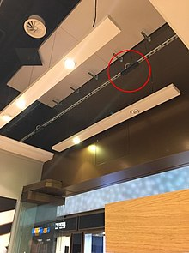

People counter seamlessly installed in a retail store

Computer visions works via an embedded device, reducing the network bandwidth usage, as only the number of people must be sent over the network. Adaptive algorithms have been developed to provide accurate counting for both outdoor and indoor locations. Multi-layer background subtraction based on color and texture, is considered the most robust algorithm available for varying shadows and lighting conditions.With the advances in image processing, video counting can achieve 98% accuracy in some lighting environments. The use of artificial intelligence and pattern recognition functions is expected to further enhance its accuracy.

### WiFi counting

WiFi counting uses a WiFi receiver to pick up unique WiFi management frames emitted from smartphones within range. While not all people carry a smartphone, WiFi counting can produce statistically significant metrics with a large enough sample size. Modern mobile operating systems, such as Apple's iOS9 and Android 6.0 Marshmallow, use MAC rotation schemes which makes WiFi counting more challenging without using sophisticated algorithms.

### Video verification

The 4th generation of people counters includes an option for users to review the authenticity and integrity of the data provided by their people counter. The user will be able to verify the accuracy of the counter and make business decisions accordingly, factoring in all the disparity of data.

### Seamless integration with store environment

People counters are designed to integrate with the store environment in order to minimize obstruction and disruption of the store environment. Furthermore, since people counters may be easily mistaken for surveillance cameras shoppers may feel uneasy and distracted if they are not properly designed and installed.

### Additional Features

Fourth-generation people counters build on previous technology to include:

1. Ability to be used in low/varying light conditions based on fusion of light receivers from multiple sources of varying intensities.
2. Features to comply with local laws that prohibit the use of CCTV in some malls while retaining the ability to obtain useful metrics from video counting.

**PROPOSED WORK:**

**3. Google Based Identification of place of interest**

# **Understanding User Behavior with Google Analytics :**

The more you know about your users, the better equipped you’ll be to make smart choices about your website, mobile app, or SaaS (software as a service) application development investments. Measure what matters, from download and first use through usage, purchases, and loyalty. Google Analytics helps you capture and understand user behavior in most kinds of applications, including mobile apps (iOS and Android), web and SaaS applications, and IOT (internet of things) devices.

With minimal instrumentation, Google Analytics provides many pieces of information to help you understand the behavior of users as they interact with your site or application. Standard metrics include the number of users interacting with your application, the number of sessions those users create, and the screens or web pages that they visit.

User data in Google Analytics is captured using either first-party cookies, randomly generated IDs, or an SDK for mobile apps. On websites and SaaS applications, users can opt-out from Analytics by installing a browser add-on, and within mobile apps, they can change their settings to opt-out (if supported by  the mobile app).

With additional instrumentation, you can gain an even richer understanding of how people interact with individual application screens or pages on a website. You can also add further instrumentation to capture more detailed interactions where needed using event tracking for granular interactions like those with video players, downloads, form submission, etc. You can also measure the number of important business actions that users complete (called Goal Conversions), as well as ecommerce transactions and purchases.

**It is divided into following parts to understand i****t:**

Every business should create a measurement plan to guide their analytics implementation. This helps you focus on the data related to your business-measurement needs. Collecting every user interaction can create a data set that is too large and difficult to analyze.

Your measurement plan should define:

* Your overall business objectives
* The strategies and tactics that support the overall business objectives
* Key performance indicators (KPIs) to measure the success of your strategies and tactics
* Segments to better understand what drives success -- this includes segmenting your marketing activities and your most valuable users
* Targets for each KPI to understand if your business is reaching its goals

To gather this information, take the time to discuss your business objectives with those people in your organization that will be using the data. This might include product designers, marketers, and others that make business decisions. Remember, you want to understand the critical pieces of information that will help people understand the performance of their business. Document their answers and create a simple measurement plan.

Now, let’s discuss some of the most important features that you can use to better measure user behavior.

### **Goals**

Goals measure how effectively your application or website supports your business objectives. A goal represents a completed activity, called a conversion, that contributes to the success of your business.

Goals fall into one of 5 types, listed in the table below:

|  |  |  |
| --- | --- | --- |
| Goal Type | Description | Example |
| Destination | A specific location loads | Thank you for registering! web page or app screen |
| Duration | Sessions that lasts a specific amount of time or longer | 10 minutes or longer spent on a support site |
| Pages/Screens per session | A user views a specific number of pages or screens | 5 pages or screens have been loaded |
| Event | An action defined as an Event is triggered | Social recommendation, video play, ad click |

## Smart Goals

In addition to the goal types described above, Analytics provides an alternative conversion tracking method called Smart Goals. Smart Goals are specifically designed to help AdWords advertisers who may not have enough conversions to use the AdWords optimization tools, such as automated bidding. When you have Smart Goals enabled, Analytics automatically evaluates your website or app visits and assigns each a score, with the "best" visits being translated into Smart Goals.

Create, edit, and share goals

You need [Edit permission](https://support.google.com/analytics/answer/6128122) at the [view](https://support.google.com/analytics/answer/6086093) level to perform the tasks or use the features described in this article.

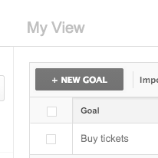

## Create a new goal

Navigate to your goals:

1. [Sign in to Google Analytics.](https://analytics.google.com/)
2. Click [Admin](https://support.google.com/analytics/answer/6132368), and navigate to the desired [view](https://support.google.com/analytics/answer/6099198).
3. In the VIEW column, click Goals.
4. Click + NEW GOAL or Import from Gallery to create a new goal, or click an existing goal to edit its configuration.  
     
   Note: If + NEW GOAL and Import from Gallery are not visible, then you have already created the maximum of 20 goals for the current view.

You have 3 basic options for creating goals:

* using a goal template
* creating custom goals
* creating Smart Goals

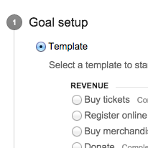

### **Option 1: Goals from a template**

Follow the [steps to create a new goal (above](https://support.google.com/analytics/answer/1032415" \l "create_edit)), then:

1. Select a Template from the list.
2. Click Next step to continue setting up your goal.

Goal templates are designed to help you set actionable goals that meet standard business objectives. You can edit any template field before saving a goal. The goal categories (Revenue, Acquisition, Inquiry, Engagement) are the larger business objectives that motivate the goal templates. Use them as an organization tool to help you think about the purpose of your goals. Try to create at least one goal for each category to get a better understanding of how users interact with your content. These categories don’t affect any data or your reports.

Don't see any templates? Goal templates are tailored to meet the needs of businesses within specific industries (automotive, entertainment, etc.). Templates are disabled if you haven't selected an industry within your account. To get templates that are relevant to your business, [edit your property](https://support.google.com/analytics/answer/1042508), select an Industry Category, and save your changes.

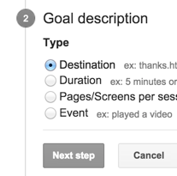

### **Option 2: Custom goals**

Follow the [steps to create a new goal (above](https://support.google.com/analytics/answer/1032415" \l "create_edit)), then:

1. Select Custom from the list of options.
2. Click Next step, then select a goal Type.
3. Click Next step again to continue setting up your goal.

See the Goal types section below for more information about setting up custom goals.

### **Option 3: Smart Goals**

If your account meets the prerequisites, you will have the option to select Smart Goals. Follow the [steps to create a new goal (above](https://support.google.com/analytics/answer/1032415" \l "create_edit)), then:

1. Select Smart Goals (if available).
2. Click Next step to continue setting up your goal.

[Learn more about Smart Goals](https://support.google.com/analytics/answer/6153083).

# What are Smart Goals?

Optimize AdWords performance using your best website sessions as conversions.

Measuring explicit conversions, using either AdWords Conversion Tracking or imported Analytics Ecommerce transactions, is the best way to optimize your bids, your ads, and your website. However, if you aren't yet measuring conversions, Smart Goals is an easy way to use your best sessions as conversions. You can then use Smart Goals to optimize your AdWords performance.

You need [Edit permission](https://support.google.com/analytics/answer/6128122) at the [view](https://support.google.com/analytics/answer/6086093) level to perform the tasks or use the features.

## How Smart Goals work

Smart Goals are configured at the [view](https://support.google.com/analytics/analytics/answer/6086093) level. Smart Goals use machine learning to examine dozens of signals about your website sessions to determine which of those are most likely to result in conversions. Each session is assigned a score, with the "best" sessions being translated into Smart Goals. Some examples of the signals included in the Smart Goals model are Session duration, Pages per session, Location, Device and Browser. ([Remarketing Smart Lists](https://support.google.com/analytics/analytics/answer/4628577) use a similar machine learning model to identify your best users.)

To determine the best sessions, Smart Goals establishes a threshold by selecting approximately the top 5% of the traffic to your site coming from AdWords. Once that threshold is set, Smart Goals applies it to all your website sessions, including traffic from channels other than AdWords. After enabling Smart Goals in Analytics, they can be imported into AdWords.

## Goal configuration options:

Use destination goals to treat a pageview or screenview as a conversion. Enter the screen name or page URL in the Destination field. Specify the match type as Equals to, Begins with, or Regular expression.

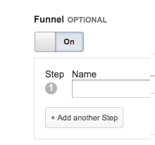

A funnel refers to the path your users take to reach a particular destination. You can specify the screens or pages the user must visit prior to the final destination goal by turning on the Funnel option. For each step in the funnel, click +Add another Step, then enter a page name or an app screen name, as you did in the Destination field.

The funnel steps use the same match type as the Destination. For example, if you specified a regular expression for the Destination, all the funnel steps must match that same expression.

Duration goal details

Measure user engagement by treating minimum session duration as a conversion. The Hours, Minutes and Seconds fields specify the minimum session time that qualifies as a goal conversion. Any session longer than this amount of time will generate a conversion..

Event goal details

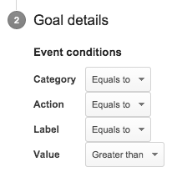

Treat user interactions with your site or app as a conversion. You must first set up at least one Event to use Event goals. Use the Event conditions to configure the event components.

Pages/Screens per session goal details

Measure user engagement by treating the number of pages or screens per session as a goal. Users who view more than the specified number of pages or screens will generate a conversion.

### Set up Smart Goals

Smart Goals require no additional set up. If your account meets the [prerequisites](https://support.google.com/analytics/answer/6153083" \l "prerequisites_for_using_smart_goals), all you need to do is select Smart Goals from the goal Types list and then give your goal a name. (That's why we called them "Smart Goals!")

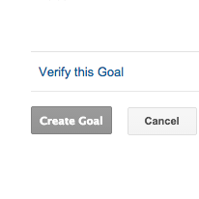

### Verify your goal

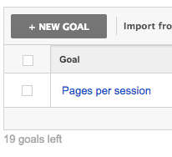

Navigate to your goals:

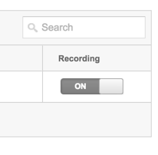

## Recording status

### To define a funnel:

1. Open or create a destination goal.
2. Turn on the funnel option, and enter a name for that step that you want to appear in the funnel reports. For example, you might want to use Welcome as the name for welcome.html.
3. Enter the URL for the first page in the funnel for Step 1.
4. To make the first step required, click the Required step toggle to turn it ON.
5. For additional funnel steps, click +Add another Step, and supply the name and URL for each page. Note: remember not to enter the final page of the process in the funnel section, but in the Destination field.
6. When you have finished adding pages, click Create goal (or Save goal).

To verify that the funnel is working, view the funnel Visualizations reports to see data there.

## Match Types: Begins with, Equals to, & Regular Expression

There are three diferent match types that define how Analytics identifies a URL for either a goal or a funnel. The match type that you select for your goal URL also applies to the URLs in the funnel, if you create one.

1. Equals to—for standard, fixed URLs:

An Equals to match is an exact match on every character in your URL—without exception—from beginning to end. Use this when your URLs for your site are easy to read and do not vary.

This option requires that the URLs you provide for your funnel or goal exactly match the URLs shown in the reports. There can be no dynamic (changing) information in the URL such as session identifiers or query parameters.

If you are using an Equals to match for a goal (e.g., /shopping/thanks.html), leading or trailing whitespaces in the destination field will invalidate the goal.

1. Begins with—to eliminate trailing URL parameters:

This matches identical characters starting from the beginning of the string up to and including the last character in the string you specify. Use this option when your page URLs are generally unvarying but when they include additional parameters at the end that you want to exclude.

If your website has dynamically generated content, use a Begins with match filter and leave out the unique values.

For example, a URL that a particular user went to might be http://www.example.com/checkout.cgi?page=1&id=9982251615. In this case, the id varies for every other user. You could still match this page by using /checkout.cgi?page=1 as the URL and selecting Begins with as your match type.

1. Regular Expression Match—for matching on multiple criteria:

A regular expression uses special characters to enable wildcard and flexible matching. This is useful when the stem, trailing parameters, or both, can vary in the URLs for the same webpage.

For example, if a user could be coming from one of many subdomains, and your URLs use session identifiers, you could use a regular expression to define the constant element of your URL. For example, checkout.cgi\?page=1 will match http://sports.example.com/checkout.cgi?page=1&id=002 as well as http://fishing.example.com/checkout.cgi?page=1&language=fr&id=119.

As another example, you could use regular expressions to set a goal for a user goes to any page in a subdirectory: ^/sports/.\*.

## Verifying Correct URL Expressions for goals

You can verify that you have written a goal URL correctly by searching for the page in the Pages report using the exact URL or regular expression you want to use in creating your goal. If you are able to successfully view the pages you expect after doing a search, you can safely assume your URL or expression will work.

Examples

Begins with

Suppose your pet store website has a number of pages in a single directory, and you want to use a Begins with match URL to create a goal only for the fish-related pages, which all have the same structure:

* /supplies/fishFood.html
* /supplies/fishTanks.html
* /supplies/fishTankDecorations.html

To determine whether your matching URI works, go to the All Pages report for your site, click the advanced button, and choose Include, Page, and Begins with before the search field. To match the URLs above, you would enter /supplies/fish in the search field. If your search returns those pages you expect to match, you can use that same URI string as your goal URL.

Regular Expression Match

Because the All Pages report allows regular expressions in the search field, it's a great place to verify whether your regular expression will work as a goal. For example, the Analytics documentation on [Google Developers Site for Analytics](https://developers.google.com/analytics/) has a number of pages that have collection as part of the file name. For example:

* https://developers.google.com/analytics/devguides/collection/analyticsjs/
* https://developers.google.com/analytics/devguides/collection/analyticsjs/advanced

While many of those files are in the /collection directory of the site, some of them don't. In order to set a goal that converts on all traffic that goes to pages with collection as part of their name, a regular expression is required. A search in the All Pages report in the [Behavior Reporting](https://support.google.com/analytics/answer/2404517) section using the regular expression .\*collection[^/]\*html$ verifies that this expression matches all files that contain collection and no other files.

# Goals and funnel steps on third-party sites

You can track a goal or funnel step page only if it contains the Analytics tracking code. However, in addition to tracking goals and funnels on your own site, you may want to track them on third-party sites. For example, you might want to track activity on a 3rd-party shopping cart site and set goals on those pages.

If you refer traffic to a third-party page on which you cannot alter the code, then you can track the outbound link as a goal or funnel step

# Track outbound links

Find out when users click a link to leave your site.

You can use Analytics [Events](https://support.google.com/analytics/answer/6086196) to track clicks on links that take users to a website other than your own.

## Access the Goal Flow report

To see the Goal Flow report:

1. [Sign in to Google Analytics.](https://analytics.google.com/)
2. [Navigate to your view](https://support.google.com/analytics/answer/6099198).
3. Open [Reports](https://support.google.com/analytics/answer/6102416).
4. Select Conversions > Goals > Goal Flow.

### Event Tracking

Events are user interactions that are tracked independently from a web-page load or screen load. You can use events to track interactions within application screens or web pages. Events are commonly used in mobile apps to understand how users share content with other users, how they use the app’s search function, and when they select specific pieces of content. Events are commonly used on websites to track file downloads, content shares, and gadget interactions. Events are extremely flexible and let you collect the data you need to better understand user behavior.

1. Select Behavior > Events.

## Anatomy of Events

An Event has the following components. An Event hit includes a value for each component, and these values are displayed in your reports.

* Category
* Action
* Label (optional, but recommended)
* Value (optional)

Event tracking for "Videos" category

|  |  |  |  |
| --- | --- | --- | --- |
| Action | Label:"Gone With the Wind" | Label:"Mr Smith Goes to Washington" | Totals |
| Play | 22 clicks across  10 sessions w/Event | 7 clicks across  5 sessions w/Event | 29 total events and  15 unique events "Play" |
| Pause | 3 clicks across  2 sessions w/Event | 16 clicks across  8 sessions w/Event | 19 total events and  10 unique events "Pause" |
| Stop | 2 clicks across  2 sessions w/Event | 4 clicks across  3 sessions w/Event | 6 total events and  5 unique events "Stop" |
| Totals | 27 total events and  14 unique events for GWTW | 27 total events and  16 unique events for Mr Smith | 54 total events and  30 unique events for category "videos" |

## Lifecycle of custom dimensions and metrics

The lifecycle of a custom dimension or metric has four stages:

* [Configuration](https://support.google.com/analytics/answer/2709828" \l "configuration) – you define your custom dimensions and metrics with an index, a name, and other properties like scope.
* [Collection](https://support.google.com/analytics/answer/2709828" \l "collection) – you send custom dimension and metric values to Analytics from your implementation.
* [Processing](https://support.google.com/analytics/answer/2709828" \l "processing) – your data is processed using your custom dimension and metric definitions and any reporting view filters.
* [Reporting](https://support.google.com/analytics/answer/2709828" \l "reporting) – you build new reports using your custom dimensions and metrics in the Analytics user interface.

#### Scope and Precedence

Scope determines which hits will be associated with a particular custom-dimension value. There are four levels of scope: product, hit, session, and user:

* Product – value is applied to the product for which it has been set (Enhanced Ecommerce only).
* Hit – value is applied to the single hit for which it has been set.
* Session – value is applied to all hits in a single session.
* User – value is applied to all hits in current and future sessions, until value changes or custom dimension is made inactive.

Product-level scope

When a custom dimension has product-level scope, the value is applied only to the product with which the value is set. Because multiple products can be sent in a single hit, multiple product-level scoped custom dimensions can be sent in a single hit.

Hit-level scope

When a custom dimension has hit-level scope, the value is applied only to the hit with which the value was set. This is demonstrated in Figure A, Figure B, and Figure C below:

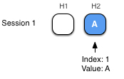 Figure A: User sends two hits (H1, H2). H2 has a CD1 value of A. That value is only applied to H2.   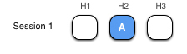 Figure B: User sends a third hit (H3). H3 has no CD value.   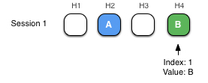 Figure C: User sends a fourth hit (H4). H4 has a CD1 value of B. That value is only applied to H4.   
  
Session-level scope

When two values with session scope are set at the same index in a session, the last value set gets precedence and is applied to all hits in that session. In Figure D below, the latest value set overwrites any previous values for that index:

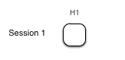 Figure A: User sends a hit (H1) with no CD value.   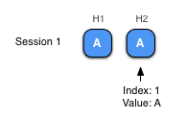 Figure B: In the same session, user sends a second hit (H2) with CD1 value set to A. Session scope causes value A to also be applied to H1.   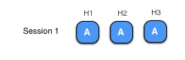 Figure C: User sends a third hit (H3). Although no CD1 value is sent with H3, session scope causes value A to be automatically applied to H3.   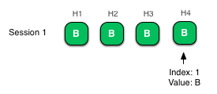 Figure D: User sends a fourth hit (H4) with a new CD1 value B. Session-scope applies value B to all the hits in the session, overwriting value A in the previous hits.   
  
User-level scope

Lastly, if two user-scoped custom dimension values are set within the same session, the last value set gets precedence for the current session, and is applied to future sessions for that user.

In Figure B below, CD value A is applied to all hits in session 2, just like a session-level CD. However in Figure C, unlike with session-level scope, the CD value A continues to be applied to hits in the third session due to CD1 having user-level scope:

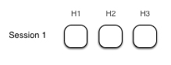 Figure A: User shas a session with three hits (H1, H2, H3). No CD values are set.   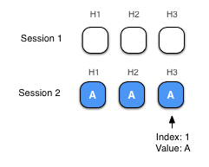 Figure B: The same user returns and has another session, with three more hits. CD1 value is set to A on H3. CD1 value is then applied to all hits in session.   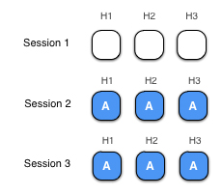 Figure C: User returns for a third session with three more hits. CD1's user-level scope causes value A to be applied to all hits in session 3.

#### Filters

View filters can interact with custom dimensions and metrics in several ways.

Custom dimension and metric values are each associated with the hit with which they were received, regardless of their scope. If that hit is filtered by a view filter, the custom dimension or metric may also be filtered, depending on its scope:

1. Hit-scope: Both custom dimensions with hit scope and all custom metrics will be filtered if the hit they are associated with was also filtered.
2. Session or User-scope: User or session-scoped custom dimensions will not be filtered even if the hit they were attached to is filtered. Their values will still be applied to all hits in the current session, as well as future sessions if the dimension has user scope.

Custom dimensions can also be used to construct view filters. This will cause hits to be filtered according to the scope of the custom dimension. For example, filtering on a user-scoped custom dimension value would filter current and future sessions from the set of users associated with that value.

## Reporting

After the collection, configuration, and other processing stages of the pipeline are complete, custom dimensions and metrics become available via the user reporting interface.

Custom dimensions and metrics are available in custom reports and available for use with advanced segments. Custom dimensions can also be used as secondary dimensions in standard reports.

## Examples

The following examples show how custom dimensions and metrics can be used by a game developer to learn about player behavior.

A game developer has recently released a new game.

The current Analytics implementation tracks a screen view each time a user plays a level. The developer already knows how many times each level is played. Now they want to answer these more advanced questions:

1. How many times are easy levels played versus medium or hard levels?
2. How many levels are played for each day in a 3-day free trial?
3. How many levels are played by users in the trial versus users who have paid for the game?

To answer these questions, custom dimensions are used to create new groupings of hits, sessions, and users.

Additionally, the developer is selling some extra features to enhance the user experience, such as "powerups". The developer is already using the category and variant fields, but wants an extra field to measure the strength of the powerup purchased. This way, the developer would be able to determine if certain powerup strengths were more popular than others.

## Hit-level scope

Let's look at an example of how the game developer can use hit-level custom dimensions to find out how many levels of each difficulty level -- easy, medium, or hard -- were played.

The developer is already tracking the number of times each level is played using screen views. Now they want to know which difficulty is getting played the most.

The report will looks like this:

|  |  |
| --- | --- |
| Difficulty | Screen Views |
| easy |  |
| medium |  |
| hard |  |

Before using custom dimensions, the developer could see total screen views by level, but they were not able to group those screen views by difficulty.

By using a hit-level custom dimension, the difficulty can be associated with each screen view, allowing reports to include the difficulty being played the most.

#### Why hit-level scope?

A user may play several levels in the course of one session. Using hit-level scope means that a difficulty value will only be associated with the screen view with which it was sent. This ensures that each level screen view can be associated with a unique difficulty.

#### Configuration

The first step to implementing a custom dimension is to define it in your property settings in the Admin section of Analytics. For this example, the custom dimension definition looks like this:

|  |  |
| --- | --- |
| Index | 1 |
| Name | Difficulty |
| Scope | Hit |
| Active | True |

# Active Users

See the number of active users for your site or app.

See Active Users data

To open the Active Users report:

1. [Sign in to Google Analytics.](https://analytics.google.com/)
2. [Navigate to your view](https://support.google.com/analytics/answer/6099198).
3. Open [Reports](https://support.google.com/analytics/answer/6102416).
4. Select Audience > Active Users.

Active Users data is available in all Analytics accounts. No changes to the tracking code are necessary.

## The metrics

The Active Users report lets you see the following metrics:

* 1-Day Active Users
* 7-Day Active Users
* 14-Day Active Users
* 28-Day Active Users

## **RESULTS:**

**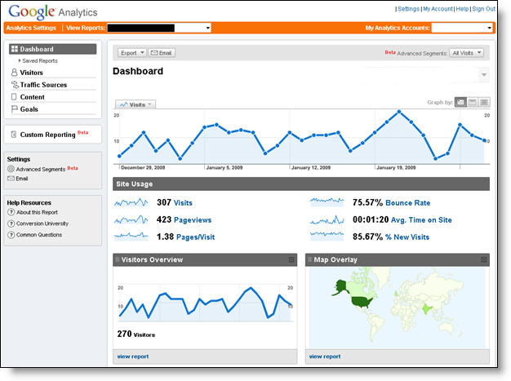**

**Dashboard**

**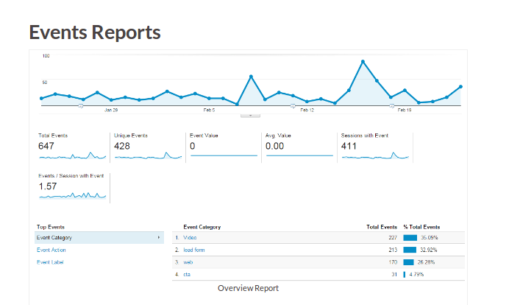**

**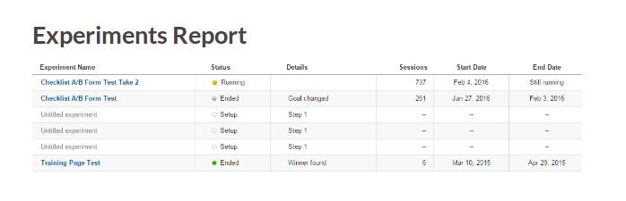**

**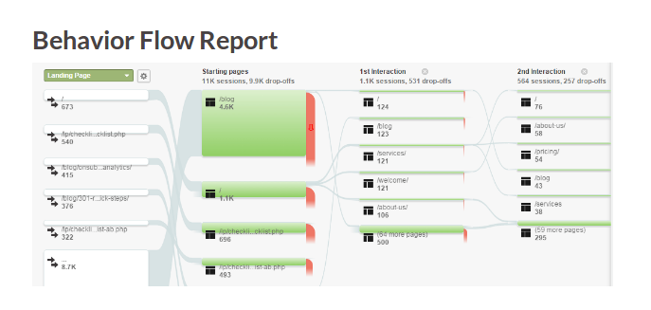**

**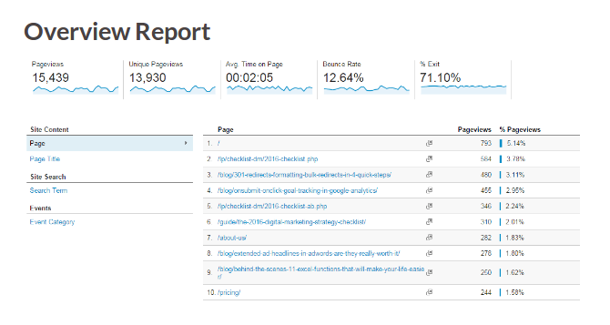**

**CONCLUSION AND FUTURE WORK:**

The main objective of this project has been to understand the behaviour of people on the basis of footfall during a public or social gathering as well to analyse the behaviour use various analytics tools.

This system can be of great importance when used in the business analytics to analyse the behavior of interacting customer as a whole as well as to understand the behaviour of people in cyber security perspective as it can effectively monitor the interaction of a particular user with the system and analyse the aspects such as his patterns of interaction that can be used to understand the interest, hobbies of that person.

While working at its full potential the system can simultaneously perform multiple tasks parallely. This may include the recognition of patterns, behavioural interests, interactions with surroundings etc.

**BIBLIOGRAPHY:**

[www.wikipedia.com](http://www.wikipedia.com/)

[www.analytics.google.com](http://www.analytics.google.com/)

[www.v-count.com](http://www.v-count.com/)

[www.quora.com](http://www.quora.com/)

[www.stackexchange.com](http://www.stackexchange.com/)